**ICT Vacuum Block**

Happens mostly at big events or session openings for futures, or sunday opening

If the swing low that formed in a diagram is becasue before that we already traded lower then this is higher probability, if price was already rallying then this is likely an exhaustion gap. Exhaustion gap is basically the last bit of momentum in the underlying trend or direction.

Vacuum block is the best when we're in a retracement on a bullish market or if weve been in downmarket and we expect some sort of bullish news. So if we gap up from a market that has been in discount

We would look at it the same as every other candle If price trades lower then well look at 2

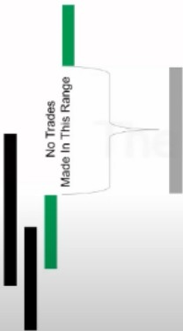

Reinfor-ing Orderblvck The ry

**Vacuum Block**

Bullish Vacuum Block is a "gap" created in Price Action as o result of a volatility event. The gop forms by a "vacuum" of liquidity directly related to an event. NFP (Nonform Poyrol] can creole a Vacuum Block or in futures a session opening con.

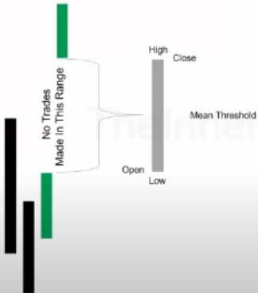

**Vacuum Block**

Bullish Vacuum Block is a "gap" created in Prk:e Action as a result of o volatility event. The gap fom,s by a ·•vacuum" ol

liquidity directty related lo on event. NFP (Nonform Poyrol] can creole a Vacuum Block or in futures a session opening con.

Reinf01 ing Orderbloc Thec;.ry

**Vacuum Block**

scenarios

1. if were bullish were looking for, is there any bullish orderblock that would cause the gap to now fill the gap entirely. If we look at this occur then we would want immediate feedback
2. If price trades lower and say we don't want to buy there, say we have a little bit stronger conviction that it will trade to the lowest downcandle and fill in the gap, the reason for expecting that is time of day sensitive, for example if its just now beginning of new york then new york will likely fill the whole gap, if the gap was late in the afternoon chances are it would leave the gap open. So if time of day permits more trading then its likely filling the gap.

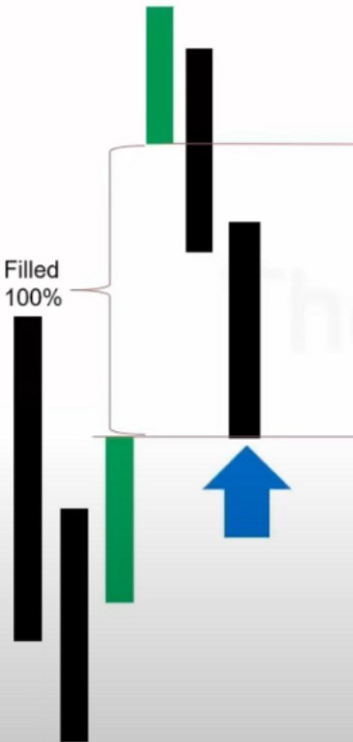

**Vacuum Block**

--=:;

Fair Value Gap

**Vacuum Block**

Perfect Delivery Of Price

A gap like this mostly happens during news embargo at 830, highly unlikely it will happen in London. If it is late in the day and the gap stays open then that will give us a fair value gap for a later time, we would look for price to cam back later to fill it in. Late in the day meaning after 1O o clock in the morning New York time

Fully rebalanced, that could be a buy at the blue arrow if we had bullish liquidity. A full return on the vacuum block.

When we close the gap and see a rally up, we never want to see price come back down below the level that closed the gap

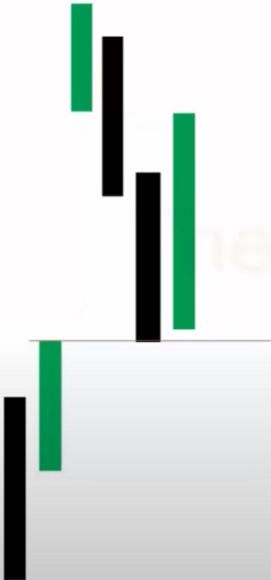

**Vacuum Block**

Theres no reason for price to come back down

A vacuum block is nothing more then a breakaway gap, because it trades a vacuum with liquidity it will not always fill completely, pif we had a bullish orderblock price may only want to come to the bullish orderblock inside that gap and then rallies higher and leaves a small gap and we can use that in a later time. But if it stays open we would label that while were bullish as a breakaway gap and it would show willigness and strength to get in there and expect higher prices

And if were expecting bullish prices and price filled in that gap meaning we had a gap up and selling then and then a rally back up so we had both selling and buying occuring there then theres no reason for price to come below that first upcandle low, if it does its suspect. Theres no reason for price to come back when it has already closed the gap

Arjo I Twitter, lnstagram I Linktree

Linktree. Make your link do more.

1 https://t.co/HhmmTN1fUI

JavaScript is not available.

***"!JI*** https://twitter.com/arjoio